* Link to my GitHub repository: <https://github.com/Baboolal-B/csd-402>
* Screenshot of my GitHub repository: 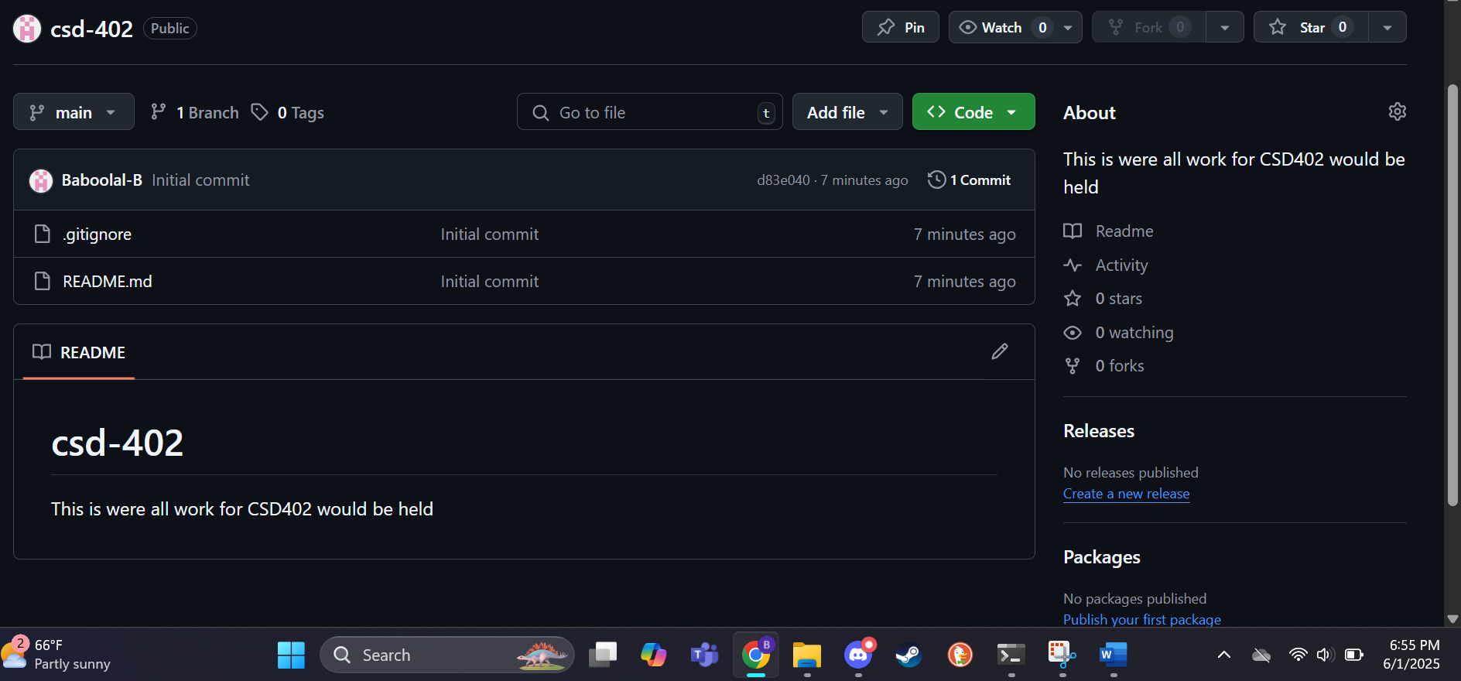
* Screenshot of my local directory (properly formatted): 